EYEWITNESS READINGS
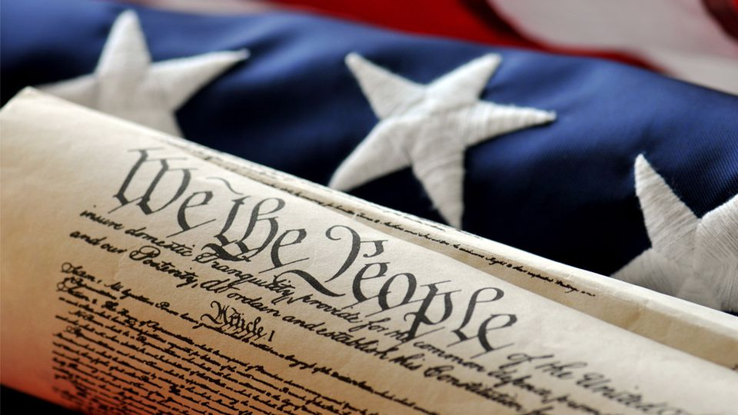

NAME: _________________________ PAGES:________ DUE DATE:_________

Directions:

- Choose 4 of the 7 activities below
- Draw a line through the ones you are omitting
- Use each reading only once
- Number 8 must be done by everyone
- Staple this sheet on top of your work
- Must be typed, on white paper, and in color when using graphics/ drawings
- If your activity is drawn, it must be neat, legible, and creative

- Write a 2 stanza (4 lines each stanza) poem (or rap!) about one event from these readings.
- Create a resume for one of the individuals in the reading. Include their credentials and information to describe their abilities. Be sure you include contact information.
- Create a catchy tourist slogan from one of places you’ve read about. (It can be satirical, tongue in cheek, etc.). Make it colorful and creative
- Which reading would make the best made-for-TV movie? What actors/ actresses would play the roles? (Cannot be a movie that has already been made.) Why would this make a good movie? This must be a paragraph.
- Design a tombstone for anyone from your reading. Be sure to include dates and a quote about their life- look them up if needed.
- Devise a Post –It note a person from these readings might have left themselves. (Make sure you indicate who has left it on the side, or on the back, not on the note itself.) Include 3-5 “reminders”
- Create a timeline of 5 different dates/events related to one of the readings and a brief explanation of each date/event. This will include the event from the reading. Add AT LEAST 2 illustrations.

EVERYBODY: Respond in a paragraph (at 5-7 sentences/ paragraph) to this question.
- To which of these events would you have most liked to have been an eyewitness? Why?

